Graphical Solution of LPP:
Def. Feasible region: The common region determined by all the constraints including non-negative constraints x, y ≥ 0 of a linear programming problem is called the feasible region (or solution region) for the problem. The region other than feasible region is called an infeasible region.
Feasible Solution : Points within and on the boundary of the feasible region represent feasible solutions of the constraints.
Solution of LPP by graphical method:
After formulating the linear programming problem, our aim is to determine the values of decision variables to find the optimum (maximum or minimum) value of the objective function. Linear programming problems which involve only two variables can be solved by graphical method. If the problem has three or more variables, the graphical method is impractical.
Working rule of Solving LPP by graphical method:
(i) State the problem mathematically
(ii) Write all the constraints in the form of equations and draw the graph
(iii) Find the feasible region
(iv) Find the coordinates of each vertex (corner points) of the feasible region. The coordinates of the vertex can be obtained either by inspection or by solving the two equations of the lines intersecting at the point
(v) By substituting these corner points in the objective function we can get the values of the objective function
(vi) If the problem is maximization then the maximum of the above values is the optimum value. If the problem is minimization then the minimum of the above values is the optimum value

Example 10.5
Solve the following LPP
Maximize Z = 2 x₁ +5x₂
subject to the conditions x₁+ 4x₂ ≤ 24
3x₁+x₂ ≤ 21
x₁+x₂ ≤ 9and x₁, x₂ ≥ 0
Solution:
First we have to find the feasible region using the given conditions.
Since both the decision variables x₁ and x₂ are non-negative, the solution lies in the first quadrant.
Write all the inequalities of the constraints in the form of equations.
Therefore we have the lines x₁+ 4x₂=24 ; 3x₁ + x₂ = 21; x₁ + x₂= 9 x₁+ 4x₂= 24 is a line passing through the points (0 , 6) and (24 , 0). [(0,6) is obtained by taking x₁=0 in x₁ + 4x₂ = 24 , (24 , 0) is obtained by taking x₂ = 0 in x₁+ 4x₂ = 24].
Any point lying on or below the line x₁ + 4x₂ = 24 satisfies the constraint x₁ + 4x₂≤ 24 .
3x₁ +x₂= 21 is a line passing through the points (0, 21) and (7, 0). Any point lying on or below the line 3 x₁ + x₂ = 21 satisfies the constraint 3 x₁ + x₂ ≤ 21.
x₁+ x₂ = 9 is a line passing through the points (0 , 9) and ( 9 , 0) .Any point lying on or below the line x₁ + x₂ = 9 satisfies the constraint x₁+ x₂ ≤ 9.
Now we draw the graph.
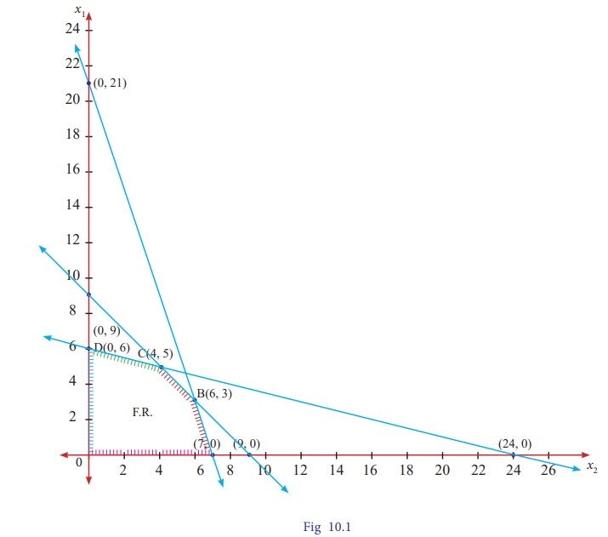

he feasible region satisfying all the conditions is OABCD.The co-ordinates of the points are O(0,0) A(7,0);B(6,3) [ the point B is the intersection of two lines x₁+ x₂= 9 and 3 x₁+ x₂= 21];C(4,5) [ the point C is the intersection of two lines
x₁+ x₂ = 9 and x₁+ 4x₂ = 24] and D(0,6).
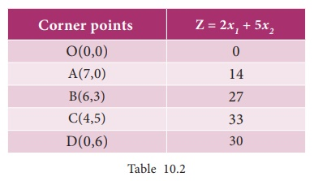
Maximum value of Z occurs at C. Therefore the solution is x₁ =4, x₂ = 5, Z _{max} = 3

