ONLINE ACTIVITIES
Online Classes taken from Academic Session 2020-21 TO 2023
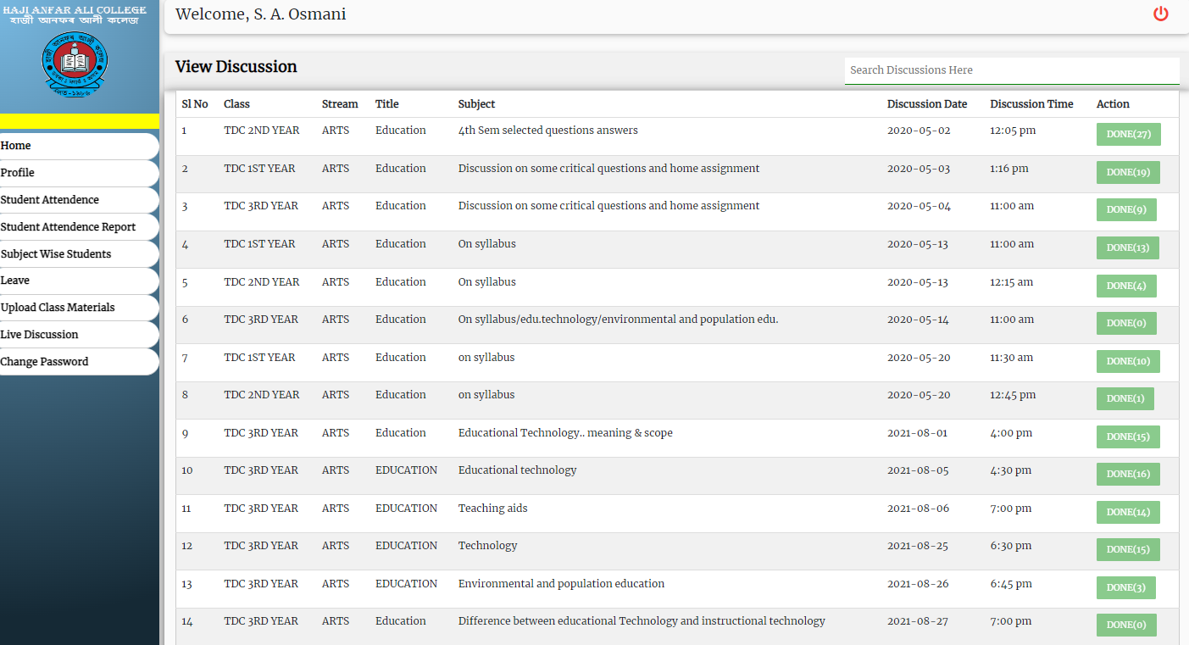

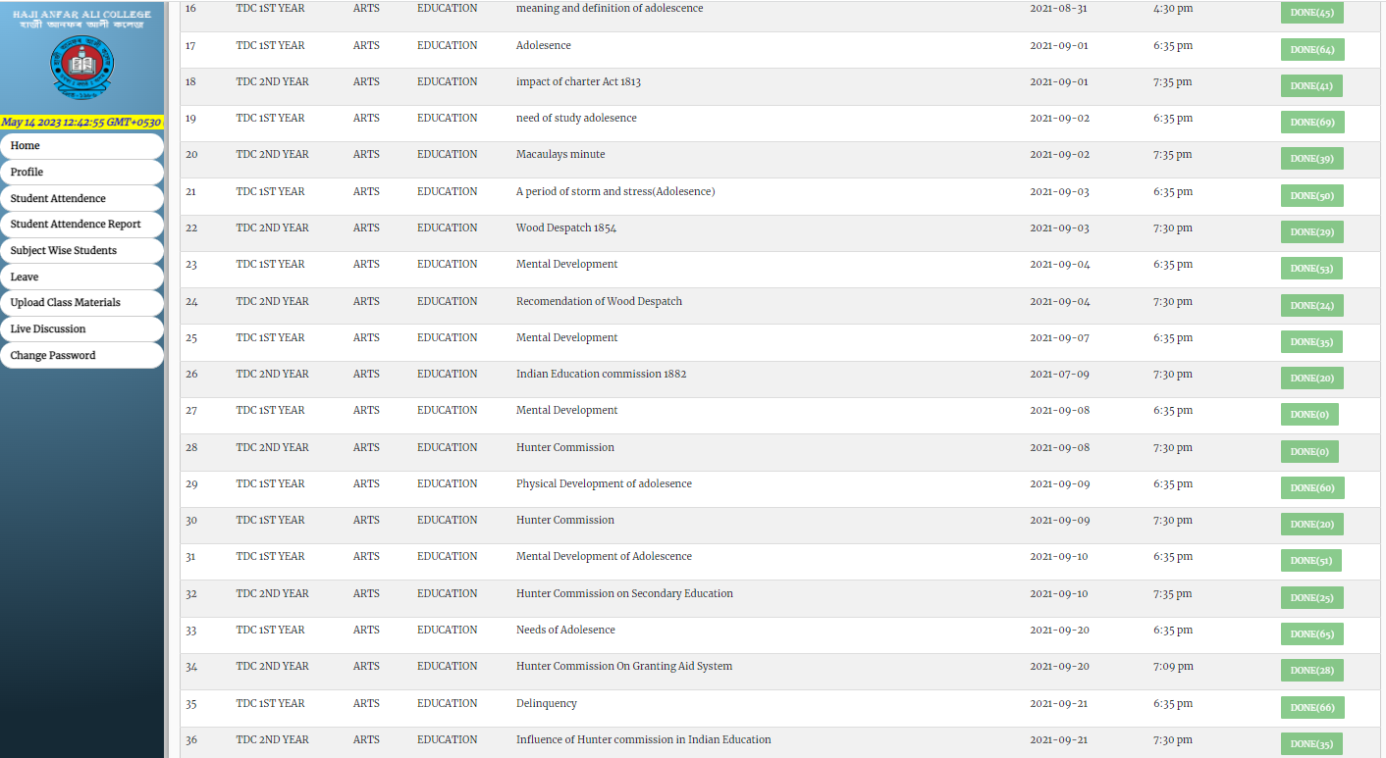

Online Activities:
Sl No | Webinar/ Seminar/Workshop/ Awareness | National/International | Date | Topic
1 | Webinar | National | 11/09/20 | School Education and NEP-2020
2 | Workshop | National | 16/17/18/ June 2020 | Capacity building of Academic Counsellor of KKHSOU
3 | Workshop | National | 26/6/20 | Effective English teaching Through Technology
4 | Workshop | National | 27/6/20 | Future of education and Accreditation.
5 | Webinar | National | 22/6/20 | Reflection on Folk culture Amid Uncertain Times
6 | webinar | National | 9/6/20 | Open and Distance Learning as Alternative
7 | Webinar | National | 22/6/20 | Awareness programme on Use of Online E-Resources
8 | Webinar | National | 25/6/20 | Mental Stress and Online education During covid -19 Pandemic
9 | Webinar | International | 25,26/6/20 | Nutrition and wellness in the time of Pandemic
10 | Webinar | National | 03/5/20 | Immuno-Nutrition, Wellness management &Livelihood Change
11 | Webinar | International | 17/7/20 | Covid -19and Global Change–in the Society and Politics
10 | Webinar | National | 11/8/20 | The Present Pandemic induced Cricis:Understsnding from an Anthropological Perspective
11 | Webinar | International | 17/8/20 | Post Covid Global Education: Challenges and opportunities
12 | Seminar | National | 15/8/20 | Reconnect with yourself.
13 | Workshop | International | 5/7/20 | Capacity Building and redesigning the Learning &Research Aptitudes
14 | Webinar | National | 7/7/20 | Children’s Mental Stress and Role of Parents
15 | E-Conference | International | 29,30/6/20 | Surpassing Boundaries to Create /critique: A praxis of female
16 | webiner | National | 13/7/20 | Rights of Women Under Personal Laws
17 | Webinar | international | 17/8/20 | The Impact of covid -19 Pandemic on Women and Family Health
18 | Webinar | National | 18/6/20 | How to Beat Stress and be motivated
19 | Seminar | National | 4/6/20 | Coping with Lifestyle and and Mental Wellness in Extraordinary Environment
20 | Webinar | International | 8/8/21 | Corvid -19Third Wave: Threats ,Preventions &Care
21 | Seminar | International | 13/3/22 | National Science Day 2022;life & Works of Sir C.V.Raman
2622 | Awareness | National | 22/6/20 | Covid 19 Awareness Programe
23 | Seminar | National | 19/8/20 | Historical and Cultural Perspectives of Indian Theatre :focusing on Assamese Theatre
24 | Conference | International | 24/8/29 | Life Skill Education :its Demands and Challenges in Day to Day life
25 | Webinar | National | 11/8/21 | Higher Education During Covid Era
26 | Faculty Development Programme | International | 28 July To -3rd August 20 | CREATIVITY AND INNOVATION IN TEACHING AND LEARNING

Off-line Activities:
Sl No | Activities/Date | Department | Institute | Topic
1 | Training, 7/8/16/to 13/8/16 | NSS | Indian Institute of Entrepreneurship-Guwahati | Orientation Programe
2 | Training Programe11-14 March -2019 | SIRDPR,  Sikkim | RGNIYD,Sriperumbudur,Tamilnadu | Training of Trainers programe on Sustainable goals-Engaging the youth
3 | Orientation Programe,20/1/10 to 18/2/10 | Education | UGC ,Academic Staff College, AMU,,Aligarh | Orientation programe
4 | Seminar 15-17 Feb-2019 | Education | USTM,Meghalaya | Teacher as Counselor,Motivator,Guide,&Visionary Introspection.
5 | Workshop,23-24 Oct,2019 | NSS | Don Bosco Institute,Ghy | Workshop on challenges & Opportunities in NSS in Assam
6 | National Seminar,4/6/16 | Education | Hojai College | New Dimension in Higher Education of ICT
7 | UGC –Workshop,  8/12/07 | Education | ADP COLLEGE | Value Based Education
8 | National Seminar,27/6/11 | Education | Ajmol Foundation | Trend of Modern Education and Perspectives of Ajmol Education Mission
9 | National Seminar,7-8 0ct,2013 | Education | Moirabari College | Role of Women Entrepreneur in the Socio –Economic Development of North East
10 | National Seminar 18-20 April 2013 | Education | Hojai College | Demographic Changes and its impact in Socio –Economic and Cultural life of the people of North East India
11 | Training ,22/1/15 | Blood Donation | Blood Bank ,B.P.Civil Hospital Nagaon | Donor Motivation Training
12 | Camp Cum Orientation,28-30,2018 | NSS | Guwahati University NSS Cell | Mega Special Camp Cum Orientation Programe
13 | International Seminer,6-7 Feb 2010 | Education | Aligarh Muslim University | Envisioning quality; Academic Professionalization in Higher Education Based on Indo –British Experiences

Additional Duties and Responsibilities:
- Perform duties and Responsibilities as PROGRAMME OFFICER NSS from 2013 to 2022
- Performing Duties and responsibilities as COORDINATOR, Study Centre, KKHSOU, Haji Anfar Ali College from 15/11/2016 to till date.
- Performing Duties and responsibilities as WARDEN, Women’s Hostel, Haji Anfar Ali College from 2016 to till date.

- Perform Duty Allotment for while Boarding and Dropping from IIE Guest house to Gauhati University for PO and Girls Volunteers during MEGA SPECIAL CAMP w.e.f.28/09/2018 to 30/09/2018 ‘
- Perform Duties as Assistant 0fficer –in –Charge to CC Examination 2017.at Haji Anfar Ali College
- Perform Duties as NODAL TEACHER to PARTICIPATE THE ASSEMBLY PROCEEDINGS 0n 3rd August 2018 with the students Group of Haji Anfar Ali College at ASSAM LEGISLATIVE ASSEMBLY GUWAHATI.
- Participate in the TRAINING OF TRAINERS ON SDGs –ENGAGING THE YOUTH FOR THE NSS PROGRAMME OFFICERs Organized by the Centre for training, Orientation and Capacity Building, RGNIYD from 11-14 march 2019at STATE INSTITUTE OF RURAL DEVELOPMENT & PANCHAYATI RAJ, SIKKIM.
- Participate in ‘STATE LEVEL SYMPOSIUM FOR STRENGTHENING OF PROTECTION AND PROMOTION OF CHILD RIGHTS THROUGH ENGAGING OF VOLUNTEERS IN ASSAM, Organized by: ASSAM STATE COMMISION FOR PROTECTION OF CHILD RIGHTS IN COLLABORATION WITH UNICEF Assam, NEDFI Convention Centre, Guwahati Assam :17-18 December 2018.
- Perform Duties as Assistant Officer –in –Charge to the semester End examination 2016 of Community College at Haji Anfar Ali College.
- Perform Duty as SUPERVISING OFFICER for the High School Leaving Certificate /High Madrassa Examination 2013 at HOJAI-A Centre, Venue Deshbandu Bidyapith H.S. School.
- Perform Duties as Assistant Officer –in –Charge to the semester End examination 2014 of Community College at Haji Anfar Ali College.
- Perform Duty as EXTERNAL EXAMINER at UDALI COLLEGE for B.A.5th semester department of Education, 2016 under Gauhati University.
- Perform Duty as Examiner for Evaluation of 3rd semester Education –Paper: EC-ii and Environmental Education –Paper 12, under NAGALAND UNIVERSITY, KOHIMA.in 2011.
- Perform Duty as SUPERVISING OFFICER for the High School Leaving Certificate /High Madrassa Examination 2011 at KACHUA Centre,
- Perform Duty as SUPERVISING OFFICER for the High School Leaving Certificate /High Madrassa Examination 2015 at KAKI H.S. School Centre,
- Perform Duties as Assistant Officer –in –Charge B.A.1st Semester Examination 2014 of Haji Anfar Ali College Under Gauhati University.
- Perform Duty as EXTERNAL EVALUATOR for GUNUTSHAV phase iii Under AXOM SARBA SIKSHA ABHIJAN MISSION, Hojai on 4-6 January 2018 for the session 2017
- Perform Duty as EXTERNAL EVALUATOR for GUNUTSHAV phase ii Under AXOM SARBA SIKSHA ABHIJAN MISSION, Nagaon District on 1-3 November 2018.
- Perform Duty as EXTERNAL EVALUATOR for GUNUTSHAV phase ii Under AXOM SARBA SIKSHA ABHIJAN MISSION, Hojai District on 9-11 October 2018.
- Perform Duty as EXTERNAL EVALUATOR for GUNUTSHAV -22 Under AXOM SARBA SIKSHA ABHIJAN MISSION, Hojai District on 5 August 2022.
- Perform Duty as EXTERNAL EVALUATOR for GUNUTSHAV -2023 Under AXOM SARBA SIKSHA ABHIJAN MISSION, Hojai District on 2-4 February 2023
- Perform Duty as EXTERNAL EVALUATOR for GUNUTSHAV -2023 Under AXOM SARBA SIKSHA ABHIJAN MISSION, Hojai District on 28 June 2022 at SREE NARASINGHASTHAN SCHOOL.
- Perform Duty as a Presiding Officer for Panchayat Election at Doboka Gaon Panchayat Election 2018.
- Perform Duty as External Examiner for TDC 5th semester Practical Examination in Education Subject at kampur College on 1/2/2020
- Perform Duty as Examiner for Theory Papers of B.A.2nd semester Major paper of Education Subject at lanka College Zone -2022
- Perform Duty as Examiner for Theory Papers of B.A.1st semester (CBCS) of Education Subject at lanka College Zone -2020
- Perform Duty as SUPERVISING OFFICER for Higher Secondary Final Examination at Lanka College -2022
- Perform Duty as SUPERVISING OFFICER for Higher Secondary Final Examination at Doboka Higher Secondary School Centre in 2023.
- Perform Duty as External Examiner for Project –Viva Examination in the subject of EDU-HC-1026: Extension Activities of B.A. 1st semester at Bright Future Model College, Pirbazar, Murajhar on 27th of January 2023.
- Member of Career & Counseling Cell of Haji Anfar Ali College.
- Convenor, Cell for Elementary Medication &First Aid in the year 2005.
- Perform duty as Supervising Officer at Rengbeng Screening Centre for Covid-19 Screening Test in 2020.
- Perform Duty as District Nodal officer for Covid -19 vaccination camp in Hojai District Nominated and appointed by Government of India, Ministry of Youth Affairs &Sports NSS, Regional Directorate, Guwahati-2021
- Preforming Duty as Assistant Electoral Roll officer for Hojai District from 2021 to till date.
- Perform duty as AOC for TET Examination 2019 at Haji Anfar Ali College Centre2019.
- Perform Duty as Supervising Officer for B.A.6th Semester Examination at Murajhar College in 2022.
- Conduct SPECIAL CAMP for NSS Unit at Modertoli Village from 6 april to 10th April 2019 at adopted village

